Analysis Report
for
Do Variations in Tuition Affect Undergraduate Incoming Student Enrollment at St. Thomas University?
Version 1.0
Prepared by Armando Zapata, Camilo Riviere, and Zimin Lu
Team Tuition
Creation: 10/13/18

Problem
Do variations in tuition cost affect the number of undergraduate full-time incoming student enrollment at St. Thomas University?

Result
2 Linear regression graphs demonstrating negative correlation between incoming students and tuition prices over a span of 10 academic years. One linear graph with training set, and another linear regression graph with the test set.
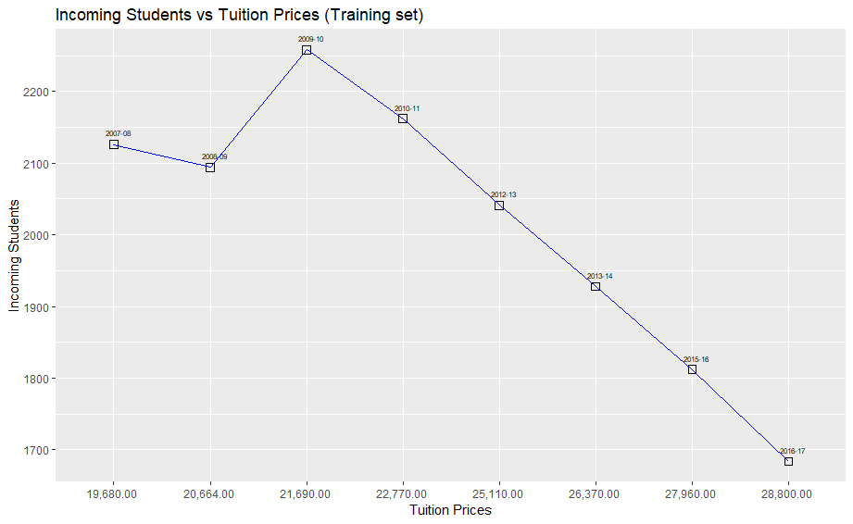

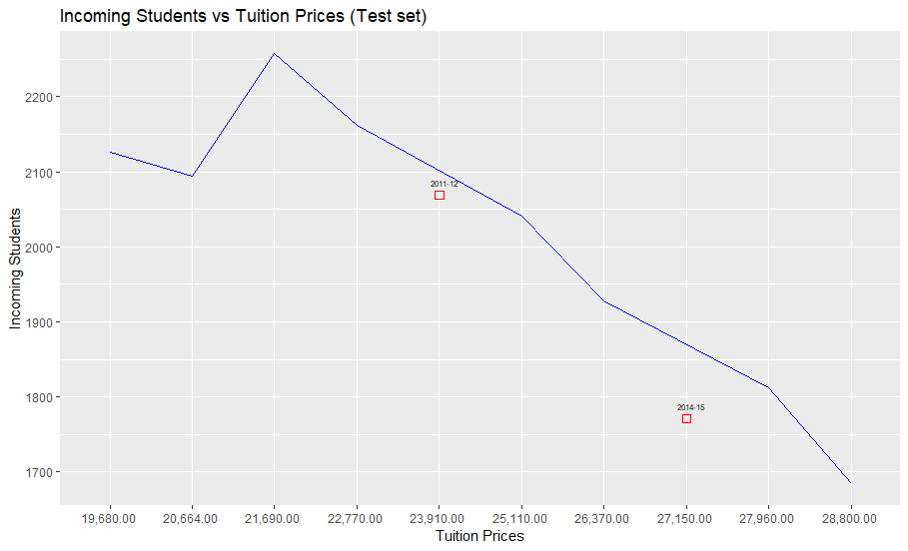

Explanation of implemented data analytics lifecycle
Phase1—Discovery

An initial assessment was done to determine the project’s viability. At first, interviews were conducted with different individuals from different departments to better understand the domain area of the problem. Similar projects previously attempted in the past by the institution was an important task because it would have provided a path and a starting point from where to start with initial hypotheses.

Part of the assessment was on the resources available to support the project. With the preliminary interviews, the scope of the problem was defined, as well as accessibility to the data, which was essential moving further in the more analytical stages.

Given the 5-week time constraint, it was decided to analyze a portion of the overall student body because there were less variations of yearly tuition costs and because the incoming undergraduate portion was more representative of the student body as a whole.

Phase 2—Data Preparation

Once it was established that the sample data required for the purposes of the project was going to be obtained, an analytics sandbox was created. In here, an analysis was performed on deciding which aspects of particular datasets will be useful to analyze in later steps. Also, ideas were formed about which data to keep and which to discard.

Although the preliminary data obtained was in a structured form, further cleaning was required in order to assess the consistency of the data. In the spreadsheet provided, for example, information about degree dates for each student was inconsistent each year and did not have a place into the overall problem of the project.

Content of data columns and other inputs was reviewed to ensure they make sense. For instance, since the project involves analyzing tuition costs for a 10-year period, a preview was done to confirm that tuition values are positive. In addition, the sample data was reviewed to gauge if the definition of each variable and sub-variables were consistent for the whole scope.

Phase 3—Model Planning

During this phase, a linear regression analysis was identified as a candidate model to apply to the data for finding a relationship. Given the problem’s 2-variable concept, and given the information at hand, a regression model will generate predictions based only on the information inputted to the model; predictions that while not 100% guaranteed, will provide a rationale for any given output the model generates.

Also, an in-depth assessment of the datasets structures was performed to determine which tools and analytical techniques were going to be used for the next phase. This was important considering the datasets were a combination of numeric and textual variables.

Phase 4—Model Building

A negative correlation of -.07501 between the independent variable and the dependent variable was established during this phase. This provided an idea as to what to expect from the model and the results it will generate. A total of 10 data points, each corresponding for each year of the scope, were aggregated to represent the total number of undergraduate incoming students and the total tuition cost for that particular year.

During the model validation process, 80% of the observations collected were used for the training set and 20% of the observations collected were used for the test set. The test set was randomly sampled.

Phase 5—Communicate Results

- The team, in collaboration with major stakeholders, determines if the results of the project are a success or a failure based on the criteria developed in Phase 1.
- The team should identify key findings, quantify the business value, and develop a narrative to summarize and convey findings to stakeholders.

Phase 6—Operationalize

A pilot project to deploy the work was not performed in this project. The purpose of this rpoject was to establish a relationship between two variables, and there was not a requirement for the model to fit smoothly either in a production environment or can be integrated into the university’s business processes.

A final Software Requirement Specification (SRS) and Software Design Specification (SDS) was generated with the details of the project. Additionally, the code for the model was submitted as well as the spreadsheet containing all the data used for the project.

Benefit
This project will yield new insights about a relationship within the institution that has not been previously explored. For the purposes of this project, the final output will serve as a stepping stone for future similar projects to lean on, and potentially draw inferences that could help create more models that could provide further insights to other problems in the institution. This project can also shed some light into different strategies that the university can implement to increase its attractiveness and possibly increase incoming enrollment.

Accuracy Evaluation
Correlation was utilized to test accuracy between Incoming students for each academic year and tuition prices. Depiction can be found below under section 6.2.

Statistics Tests

Classes of tests
Correlation – Used to test relationship between Incoming students for each academic year and tuition prices.

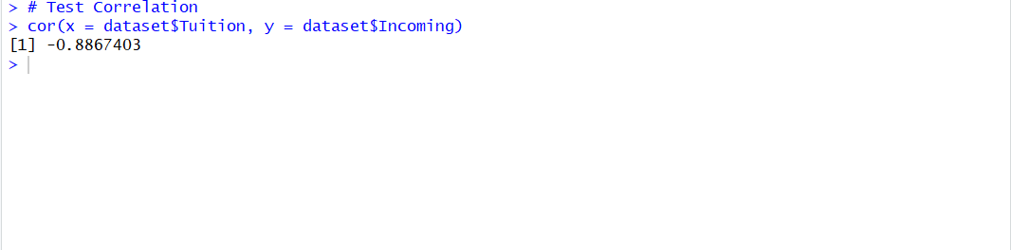
Expected response

Performance bounds
Performance bounds are subject to the limitations of the hardware of our execution machine:
RAM- 8GB
Hard drive – 80GB
Processor – Intel i5

External review and validation
The validation process for the model was done by performing a series of testing sets. Among them was the 80-20 test, in which 80% of the observations collected were used for the training set and 20% of the observations collected were used for the test set. The test set was randomly sampled.

For this project, there is not an ideal way to externally test the model, especially since the purpose of the project is to identify a relationship between two variables.

References
Appendix A: Glossary
Correlation – A mutual relationship or connection between two or more things.
Linear Regression – In statistics, linear regression is a linear approach to modelling the relationship between a scalar response (or dependent variable) and one or more explanatory variables (or independent variables). The case of one explanatory variable is called simple linear regression.
Data model – A data model is an abstract model that organizes elements of data and standardizes how they relate to one another and to properties of the real world entities.
White-box testing – White box testing is a method of testing software that tests internal structures or workings of an application, as opposed to its functionality. In white-box testing an internal perspective of the system, as well as programming skills, are used to design test cases.
Black-box testing – Black-box testing is a method of software testing that examines the functionality of an application without peering into its internal structures or workings. This method of testing can be applied virtually to every level of software testing: unit, integration, system and acceptance.
Subset – A set of which all elements are contained in another set.
Appendix C: Issues List
- Result interpretation is a potential issue since this is the first time this type of analysis has been done for St. Thomas university.

- External data such as currency inflation was not considered in the analysis due to time constraints.

- Tidying procedures vary depending on the specific project and the model used, therefore selecting the right tidying method for the data will require a careful evaluation and may pose issues deeper into the analytical stages.

